**CHAPTER 1**

**INTRODUCTION**

The introduction chapter gives you an introduction about the HTML and its real time applications. The main idea behind this project is to provide the facility to the students to interact with their seniors using this placement zone.

**1.1HYPERTEXT MARKUP LANGUAGE(HTML)**

**Hypertext Markup Language** (**HTML**) is the standard markup language for creating web pages and web applications. With Cascading Style Sheets (CSS). Web browsers receive HTML documents from a web server or from local storage and render the documents into multimedia web pages. HTML describes the structure of a web page semantically and originally included cues for the appearance of the document. HTML provides a means to create structured documents by denoting structural semantics for text such as headings, paragraphs, lists, links, quotes and other items.

**1.2HYPERTEXT MARKUP LANGUAGE IN WEBPAGE CREATION**

A basicwebsite can be designed by using Hyper Text Markup Language (HTML). The scripts can be written in Notepad or a text document depending on the operating system which you use .The very basic tools for creating a website start with the use of HTML **tags** and HTML **elements**. The former are often used to pass on information about the unit of the content and the latter ones are used to format tools for the webpage.

**1.3CASCADING STYLESHEET(CSS)**

**CSS** stands for Cascading Style Sheet and is used by web pages tohelp keep information in the proper display format.**CSS files** can help definefont size, color, spacing, border and location of HTML information on a web page, and can also be used to create a continuous look throughoutmultiple pages of a website.CSS describes how HTML elements are to be displayed on screen, papers or in other media CSS saves a lot of work. The software that are required for the implementation of the project phase and their detailed specification.

**CHAPTER 2**

**SYSTEM SPECIFICATIONS**

**2.1 SOFTWARE REQUIREMENTS**

Operating system : Windows

Browser : Chrome

Editor : Notepad++

Server : XAMPP

**2.2 SOFTWARE OVERVIEW**

**CHROME**

**Chrome** is an open-source Web browser project started by Google, to provide the source code for the proprietary Google Chrome browser. The two browsers share the majority of code and features, though there are some minor differences in features and logos, and they have different licensing.

**NOTEPAD++**

**Notepad++** is a text editor and source code editor for use with Microsoft Windows. It supports tabbed editing, which allows working with multiple open files in a single window. The project's name comes from  C increment operator. Notepad++ is distributed as free software.

**XAMPP SERVER**

**XAMPP** is a free and open source cross-platform web server solution stack package developed by Apache friends, consisting mainly of the Apache HTTP server,MariaDB database and interpreters for scripts written in the PHP and Perl programming language. XAMPP stands for Cross-platform(X) ), Apache (A), MariaDB (M), PHP (P) and Perl (P). It is a simple, lightweight Apache distribution that makes it extremely easy for developers to create a local web server for testing and deployment purpose. XAMPP is also cross-platform, which means it works equally well on Linux, Mac and Windows.

**CHAPTER 3**

**DESIGN METHODOLOGY**

**3.1 PROBLEM DEFINITION**

The reasons why juniors are not interacting their seniors are

1. Juniors do not know how to approach seniors.
2. Seniors may not be available every time.
3. Juniors may hesitate to interact with seniors face to face conversation.

**3.2 METHODOLOGY**

The idea is to make the students to interact with their seniors. This idea will help all the students to ask their queries to seniors and can clarify their doubts with seniors. Also they can be friendly with others as much as possible since they are not limited to any restrictions.

**CHAPTER 4**

**IMPLEMENTATION**

Implementation of each module in this project is described here.

The proposed project consists of these modules.

* Login page
* Home page and details about placed students
* Discussion forum

**4.1 LOGIN PAGE**

Login page is created using two major credentials namely user id and password. User id is register number provided by college management which is used to find year,department and roll number and is unique for every student. Password should be given by user while logging in into the website. During sign up of the account one has to enter password and that will be used on every login. This password system provides security from other people and students can use and manage their accounts safely.

**CHAPTER 4**

**IMPLEMENTATION**

This chapter discusses the implementation of each module in this project.

The proposed project consists of these modules.

* Login page
* Home page and details about placed students
* Discussion forum

**4.1 LOGIN PAGE**

Login page is created using two major credentials namely user id and password. User id is register number provided by college management which is used to find year,department and roll number and is unique for every student. Password should be given by user while logging in into the website. During sign up of the account one has to enter password and that will be used on every login. This password system provides security from other people and students can use and manage their accounts safely.

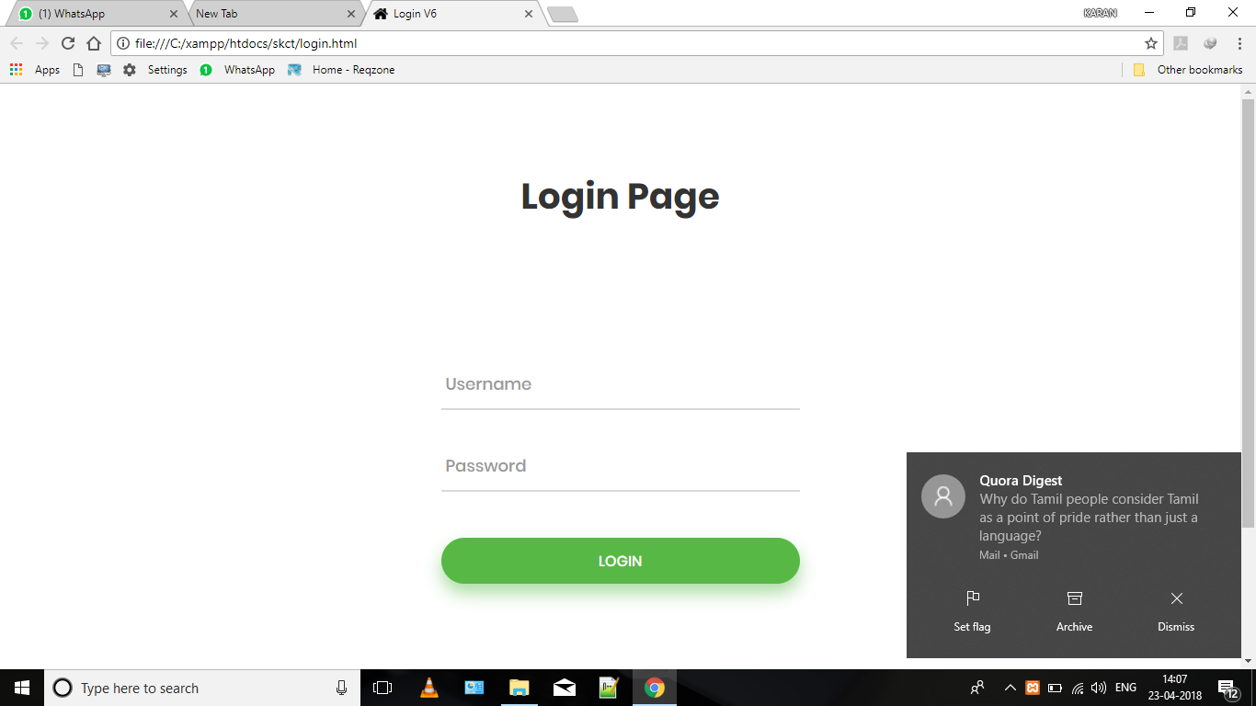

**Figure 4.1 Login page**

**4.2HOME PAGE AND DETAILS ABOUT PLACED STUDENTS**

Home page has introduction about placement and college gallery and the details of placed students are in the separate page where people can know about the status of the placement. It consists of name of the student along with his/her register number so that we can know about department and year of the student and also the company in which he/she got placed. Also another separate page is available for contact which consist of the details of the placement officer and contact details about him. Another page is available to know the students who are all signed up in the website. This might help them to know their friends in the zone.

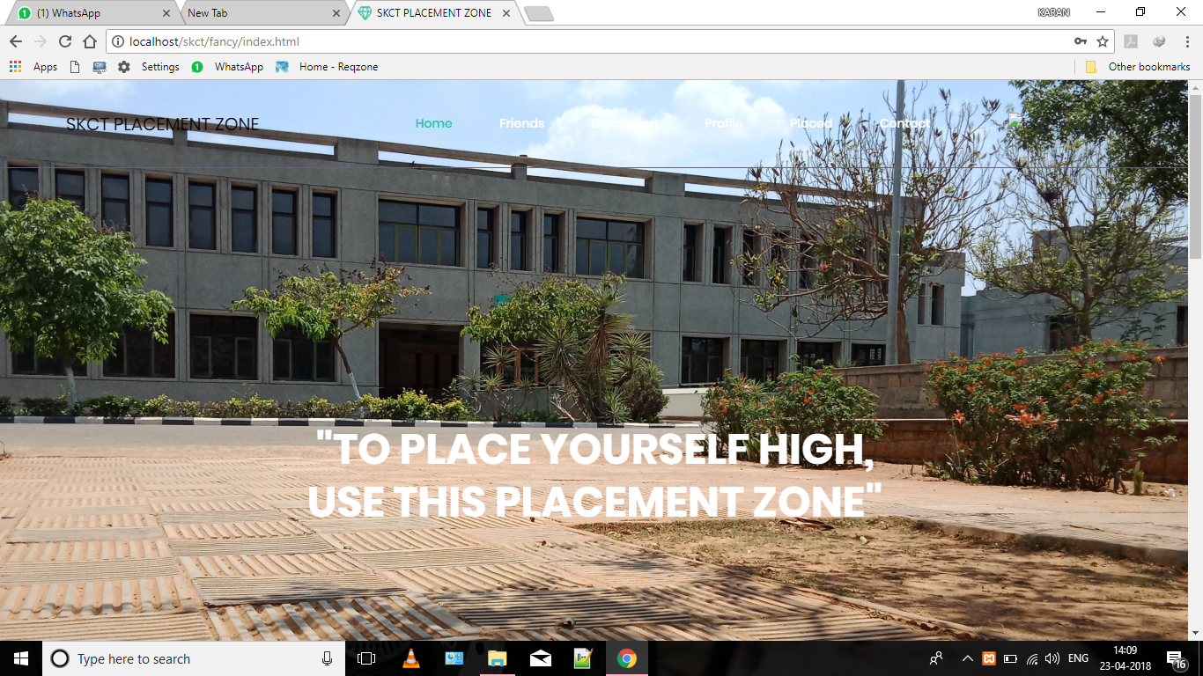 **Figure 4.2 Home page**

**4.3DISCUSSSION FORUM**

In discussion forum students can post their queries and doubts about their placement to their seniors. Anybody who can able to clear the doubt asked can reply to it. Especially senior students who got placed can share their experiences and questions they faced in the interview. This would be helpful for the students who are going to face the interview and can get some ideas about the placement and interview. Each comment will be displayed with the username i.e the register number.

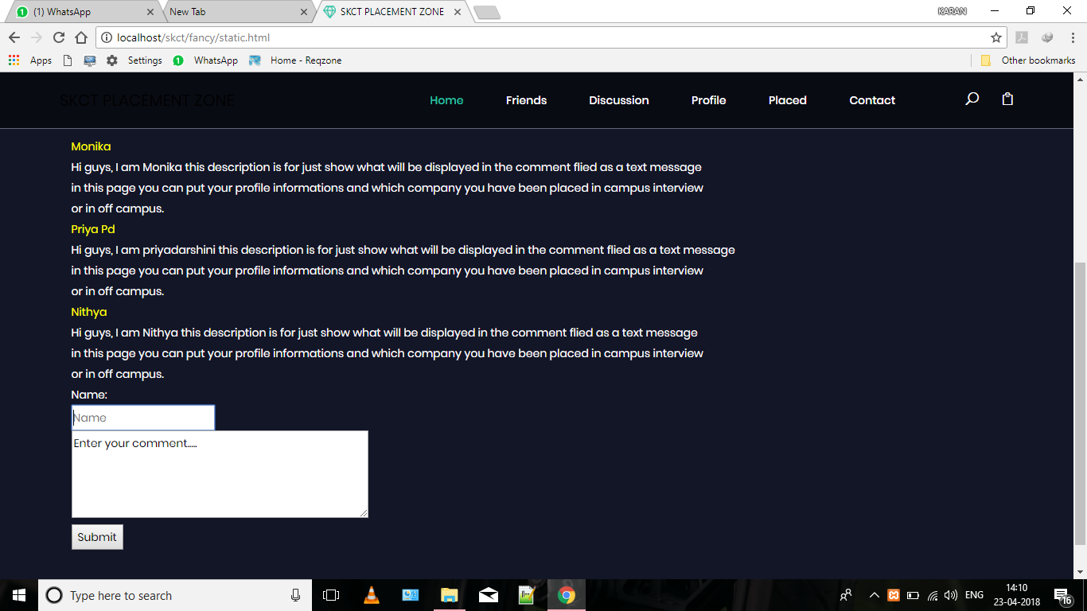

**Figure 4.3 Discussion forum**

**4.4 DATABASE**

Database is collection of data which is stored for future use. Database has to be connected with front end in order to display it to the user. PHP is used here to connect with database. PHP is Hypertext Preprocessor is an HTML-embedded, server-side scripting language designed for an

Use called web development. It is also used as a general purpose programming language. Here PHP is used ma development. It is also used as a general purpose programming language.Here PHP is used mainly for connectivity between front end and database.

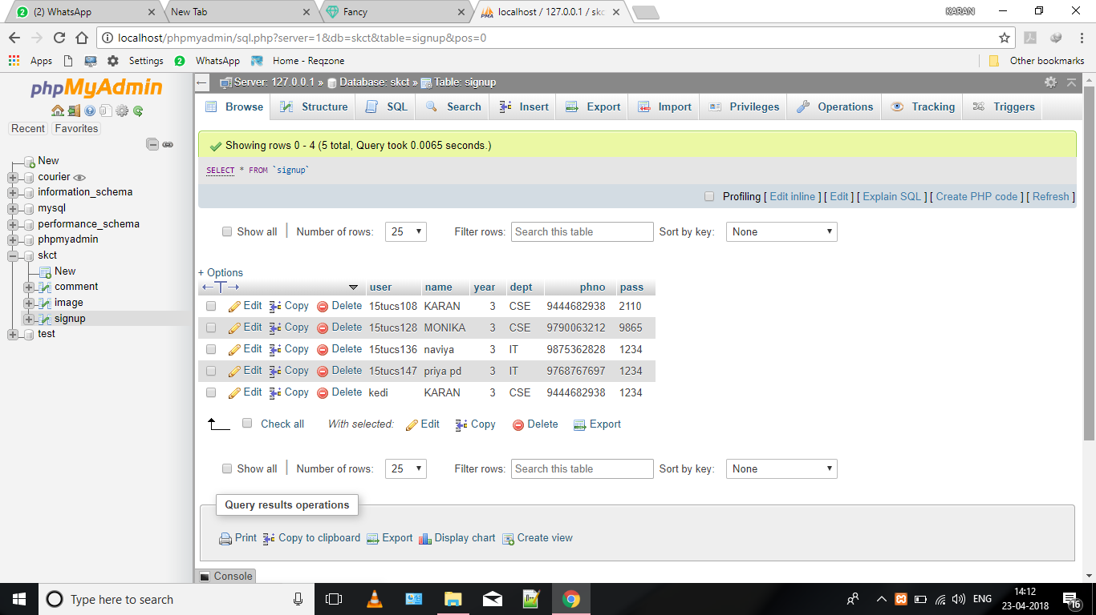

**Figure 4.4 Database outlook**

**4.5 RESET PAGE**

If you forget your password you can reset with new password and can use new password for further login.

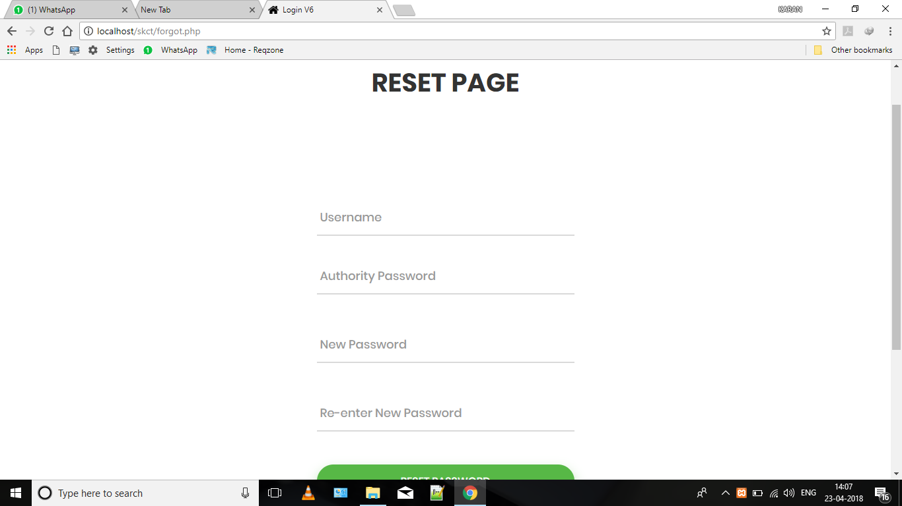

**Figure 4.5 Reset page**

**4.6 CONTACT**

Contact us section provides information about the admin of the application. The details about the address of college and availability are provided here. Feedback can be send to admin by this section. Doubts and queries can be asked with admin via mail.

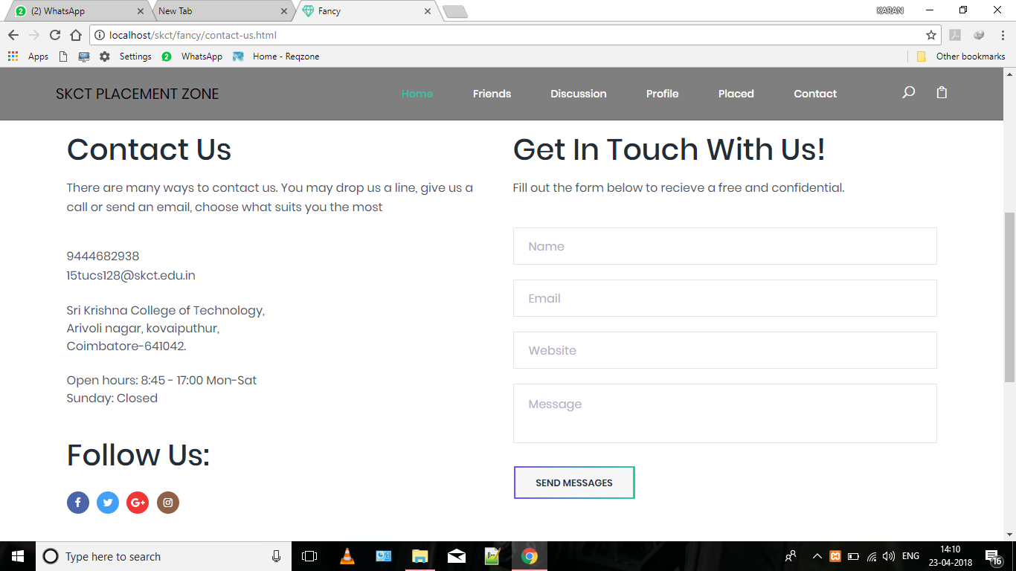

**Figure 4.6 Contact page**

**CHAPTER 5**

**CODING**

**5.1 HTML LOGIN PAGE**

<!doctype html>

<html>

<head> <link rel="stylesheet" href="style.css">

<?php

$servername = "localhost";

$username = "root";

$password = "";

$dbname = "skct";

$user1=" ";

$pass1=" ";

$dbusername="";

$dbpassword="";

$result="";

if(isset($_POST["user"])){

$user1 = htmlspecialchars(trim($_POST["user"]));} if(isset($_POST["pass"])){

$pass1 = htmlspecialchars(trim($_POST["pass"]));}

if($user1==" "||$pass1==" "){

$curl = curl_init();

curl_setopt($curl, CURLOPT_URL, "http://localhost/skct/index.html");

curl_setopt($curl, CURLOPT_RETURNTRANSFER, 1);

$result1 = curl_exec($curl);

curl_close($curl);

print $result1;

$message = "You must enter both Username or Password.\\nTry again.";

echo "<script type='text/javascript'>alert('$message');</script>";}

else{

$conn1 = new mysqli($servername, $username, $password, $dbname);

if (!$conn1) {

die("Connection failed: <br>" . $conn1->connect_error);}

$sql = "SELECT userid,password FROM signup WHERE user='$user1' AND pass='$pass1'";

$result = $conn1->query($sql);

if($result->num_rows>0) {

while($row = $result->fetch_assoc()) {

$dbusername=$row['user'];

$dbpassword=$row['pass']; }

if($user1 == $dbusername && $pass1 == $dbpassword) {

$curl = curl_init();

curl_setopt($curl, CURLOPT_URL, "http://localhost/skct/new.html");

curl_setopt($curl, CURLOPT_RETURNTRANSFER, 1);

$result1 = curl_exec($curl);

curl_close($curl);

print $result1;}

else {

$curl = curl_init();

curl_setopt($curl, CURLOPT_URL, "http://localhost/skct/index.html");

curl_setopt($curl, CURLOPT_RETURNTRANSFER, 1);

$result1 = curl_exec($curl);

curl_close($curl);

print $result1;

$message = "Username or Password incorrect.\\nTry again.";

echo "<script type='text/javascript'>alert('$message');</script>";}

}

?>

</body> </html>

**CHAPTER 6**

**CONCLUSION AND FUTURE SCOPE**

Placement interaction web zone can be developed into an application which can be installed in mobile phones and computers and can be used. More security features for login can be included like fingerprint detection and face recognization. Some faculty members can also be included and given login id to review what is going on in the discussion forum. If needed, also some contact details and personal details can be included which is optional to each user.

**REFERENCES**

[1] McConnell, Steve (June 2004). Code Complete, Second Edition. Microsoft Press. p. 960. ISBN 0-7356-1967-0.

[2] McConnell, Steve (July 2, 1996). Rapid Development. Microsoft Press. p. 680. ISBN 1-55615-900-5.

[3] Rozanski, Nick; Eóin Woods (April 20, 2005). Software Systems Architecture: Working With Stakeholders Using Viewpoints and Perspectives. Addison-Wesley Professional. p. 576. ISBN 0-321-11229-6.

[4] Leffingwell, Dean; Don Widrig (May 16, 2003). Managing Software Requirements: A Use Case Approach, Second Edition. Addison-Wesley Professional. p. 544. ISBN 0-321-12247-X.

[5] https://www.w3schools.com/

[6] https://www.javatpoint.com/html-tutorial